WEEK - 8
Yash Raj
SuperSet ID - (6364442)

Git-HOL
Installing Git
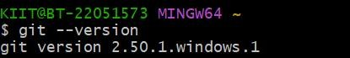
Configuring the username and user-email
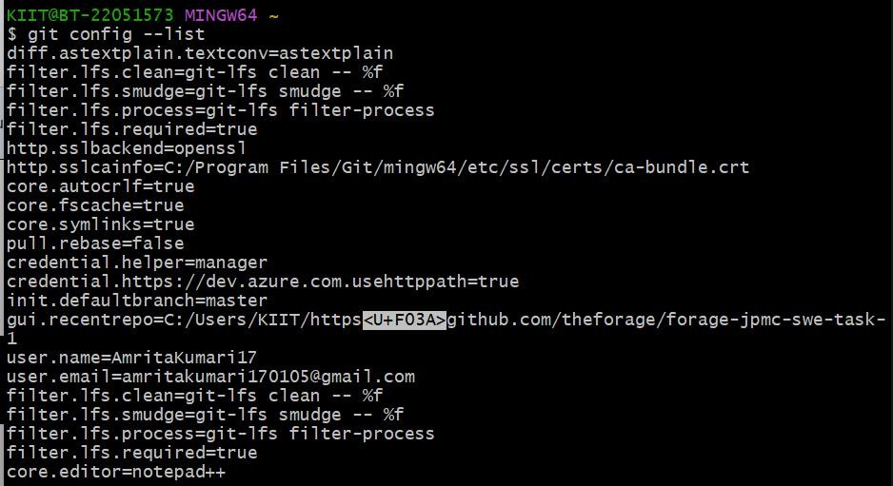
Making new folder and initializing git
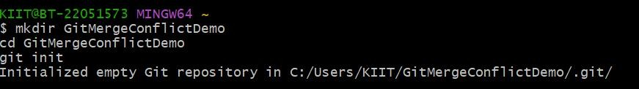

  - Verify if master is in clean state.
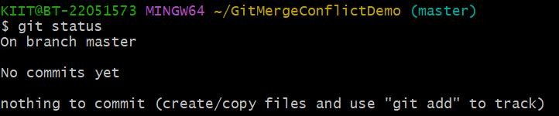
  - Create a branch “GitWork”. Add a file “hello.xml”.
  - Update the content of “hello.xml” and observe the status
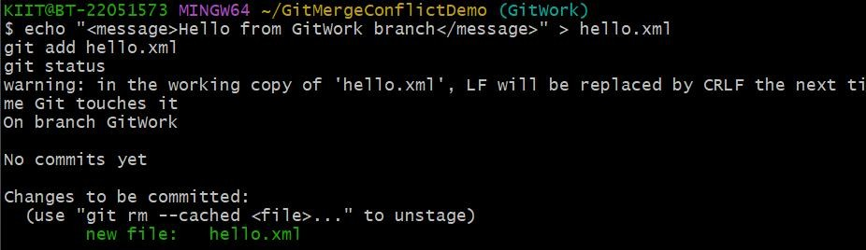
  - Commit the changes to reflect in the branch
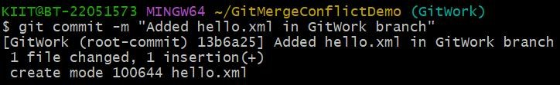
  - Switch to master.
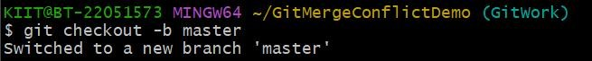

  - Add a file “hello.xml” to the master and add some different content than previous and 7. Commit the changes to the master
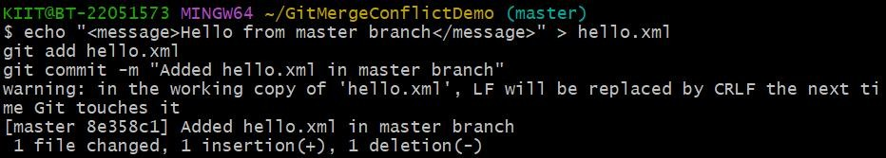
- Observe the log by executing “git log –oneline –graph –decorate –all”
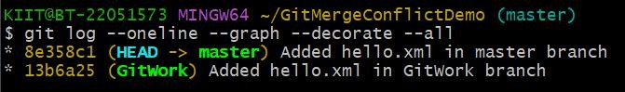
- Check the differences with Git diff tool
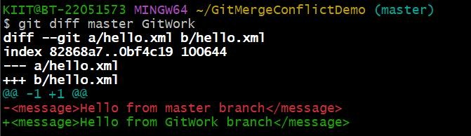
- For better visualization, use P4Merge tool to list out all the differences between master and branch
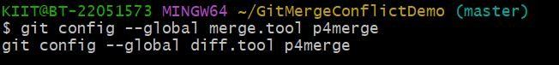
- Merge the bran to the master
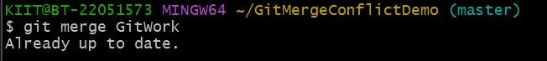

- Observe the git mark up.
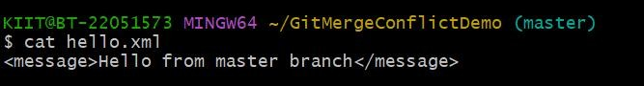
- Use 3-way merge tool to resolve the conflict
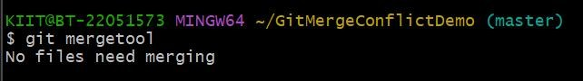
- Commit the changes to the master, once done with conflict
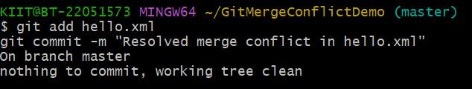
- Observe the git status and add backup file to the .gitignore file and 16. Commit the changes to the .gitignore
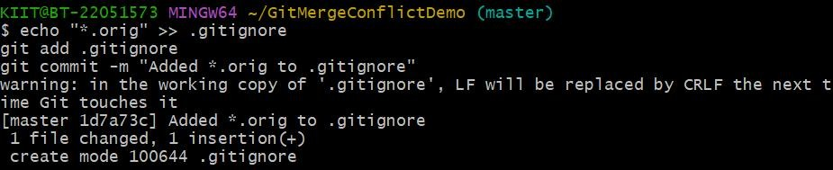
- List out all the available branches
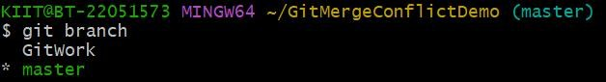

- Delete the branch, which merge to master.
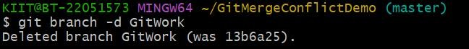
- Observe the log by executing “git log –oneline –graph –decorate”
